**LAB 6**

**OBJECTIVE**

To detect edges in an image and perform erosion and dilation

**THEORY**

Edge detection is an image processing technique for finding the boundaries of objects within images. It works by detecting discontinuities in brightness. Edge detection is used for image segmentation and data extraction in areas such as image processing, computer vision, and machine vision. Common edge detection algorithms include Sobel, Canny, Prewitt, Roberts, and fuzzy logic methods.

Morphology is a broad set of image processing operations that process images based on shapes. Morphological operations apply a structuring element to an input image, creating an output image of the same size. In a morphological operation, the value of each pixel in the output image is based on a comparison of the corresponding pixel in the input image with its neighbors.

The most basic morphological operations are dilation and erosion. Dilation adds pixels to the boundaries of objects in an image, while erosion removes pixels on object boundaries. The number of pixels added or removed from the objects in an image depends on the size and shape of the structuring element used to process the image. In the morphological dilation and erosion operations, the state of any given pixel in the output image is determined by applying a rule to the corresponding pixel and its neighbors in the input image. The rule used to process the pixels defines the operation as a dilation or an erosion.

In dilation, the value of the output pixel is the maximum value of all pixels in the neighborhood. In a binary image, a pixel is set to 1 if any of the neighboring pixels have the value 1. Morphological dilation makes objects more visible and fills in small holes in objects.

In erosion, the value of the output pixel is the minimum value of all pixels in the neighborhood. In a binary image, a pixel is set to 0 if any of the neighboring pixels have the value 0. Morphological erosion removes islands and small objects so that only substantive objects remain.

**CODE**

% Program 1 : Edge finding

a=imread('image.jpg');

a=rgb2gray(a);

[r, c]=size(a);

a=im2double(a);

filter=[-1 -1 -1;-1 8 -1; -1 -1 -1];

result=a;

for i=2:r-1

for j=2:c-1

sum=0;

row=0;

col=1;

for k=i-1:i+1

row=row+1;

col=1;

for l=j-1:j+1

sum = sum+a(k,l)*filter(row,col);

col=col+1;

end

end

result(i,j)=sum;

end

end

subplot(2,2,1)

imshow(a),title('Original Image');

subplot(2,2,2)

imshow(result),title('Edge Detected Image');

**OUTPUT**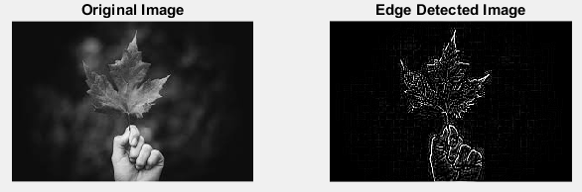

**CODE**

% Program 2 : Morphological operations : Erosions & Dilation

f=imread('image.jpg');

B=[0 1 1;1 1 1;0 1 0];

f1=imdilate(f,B);

se=strel('disk',10);

f2=imerode(f,se);

figure,imshow(f)

title('Original Image');

figure,imshow(f1)

title('Dilated Image');

figure,imshow(f2)

title('Eroded Image');

**OUTPUT**

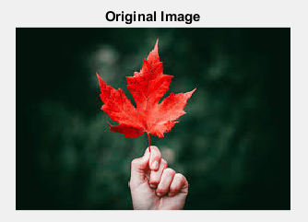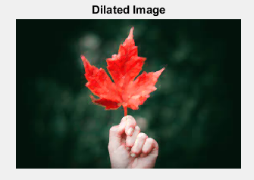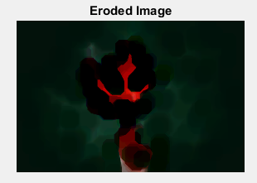

**CONCLUSION**

In this lab, I got familiar with the process of detecting edges in an image and performed dilation and erosion.